# **iMayflower Masters R&D Studentship 2021/22**

**Information for Students**

**Are you considering applying for a Masters with the University of Plymouth Faculty of Arts, Humanities and Business in 2021?**

**Do you have an interest in exploring how digital fabrication and immersive media technologies could help businesses to innovate, grow or increase productivity?**

**Are you keen to work collaboratively with a local business to apply your knowledge in a work context, through a research project that contributes to the development of a new product, service or experiential offering?**

**Overview**

As part of the University of Plymouth’s commitment supporting businesses through the economic recovery period and our ongoing drive to connect our students with industry, we are piloting a new initiative to pair highly skilled Masters level students from across our [Faculty of Arts, Humanities and Business](https://www.plymouth.ac.uk/about-us/university-structure/faculties/arts-humanities-business) with local businesses in order to undertake a defined R&D challenge.

The scheme is designed to deliver mutual benefits - helping to increase the innovation capacity of the business and deliver an unprecedented learning experience for our students.

Each project will typically last for 9 months, starting in October 2021, and will be a collaboration between a business, a student and the University.



The successful student will receive a scholarship of £3000 towards their course fees. The business (Sponsor) will also receive a stipend of up to £2000 towards agreed costs for materials, travel and accommodation directly associated with the project.

Students will receive joint supervision from the business and University staff, and will be encouraged to spend a minimum of 1 month (over the lifetime of the project) within the business, addressing the challenge as part of their Masters studies.

**Roles and Responsibilities**

All projects delivered through this scheme are governed by a formal Studentship Agreement which must be signed by all parties prior to commencement. The following sub-sections briefly summarise the main responsibilities of each party:

***Student***

* Agrees to undertake a Masters R&D Scholarship, leading the project to address the R&D Challenge identified by the Sponsor and working proactively throughout the course of the project to achieve objectives
* Works on the project in the course of completing their Masters
* Endeavours to spend sufficient time within the business to receive professional mentoring from the workplace supervisor and progress the project
* Participates in quarterly local management meetings to monitor and review progress, and address any issues (in collaboration with the University and Sponsor)
* Notifies the University immediately of any significant issues and risks that put the project, or their participation in the project, at risk
* Maintains professional confidentiality, taking into account commercial sensitivities
* ***Financial commitment:*** course fees remaining after the £3000 scholarship provided by the University

***Business*** *(the Sponsor)*

* Identifies and defines a suitable R&D Challenge, including an accurate description of the project being offered, the duties and activities involved, and the skills required
* Participates in the recruitment process to appoint a suitable student (in collaboration with the University)
* Provides the commercial environment for the student and hosts them virtually and in the workplace
* Appoints a workplace supervisor to oversee workplace induction, day-to-day project supervision and to be available for student enquiries
* Ensures the student participates in the project as agreed (in collaboration with the University)
* Ensures that the activities undertaken by the student are sufficient to contribute to the student’s Masters programme (in collaboration with the University Academic Supervisor)
* Participates in quarterly local management meetings to monitor and review progress, and address any issues (in collaboration with the University and student)
* Notifies the University immediately of any significant issues and risks that put the project, or the student’s participation in the project, at risk
* Allows the project to be disseminated (taking into account any commercial sensitivities)
* Undertakes detailed evaluation of the project, giving consideration to human resource required for next stage of development
* Considers delivering guest lectures at the University wherever appropriate
* ***Financial commitment:*** agreed costs for any materials, travel and accommodation directly associated with the project, above and beyond the stipend of up to £2000

***University***

* Provides support to the Sponsor to identify a suitable R&D Challenge and plan the project
* Advertises the R&D Challenge and coordinates the recruitment process to appoint a suitable student (in collaboration with the Sponsor)
* Appoints an Academic Supervisor to provide day-to-day guidance and support to the student and Sponsor
* Ensures that the activities undertaken by the student are sufficient to contribute to the student’s Masters programme (in collaboration with the Sponsor)
* Ensures that the student participates in the project as agreed (in collaboration with the Sponsor)
* Supervises and provides pastoral care to the student
* Provides access, where possible, to university R&D facilities
* Participates in quarterly local management meetings to monitor and review progress, and address any issues (in collaboration with the Sponsor and student)
* ***Financial commitment:*** scholarship of £3000 towards the student’s course fees, stipend of up to £2000 towards materials, travel and accommodation directly associated with the project, plus travel and subsistence for University staff

**Application Process**

Scholarships will be awarded through a staged application process with projects commencing in October 2021.

The application process is detailed below:

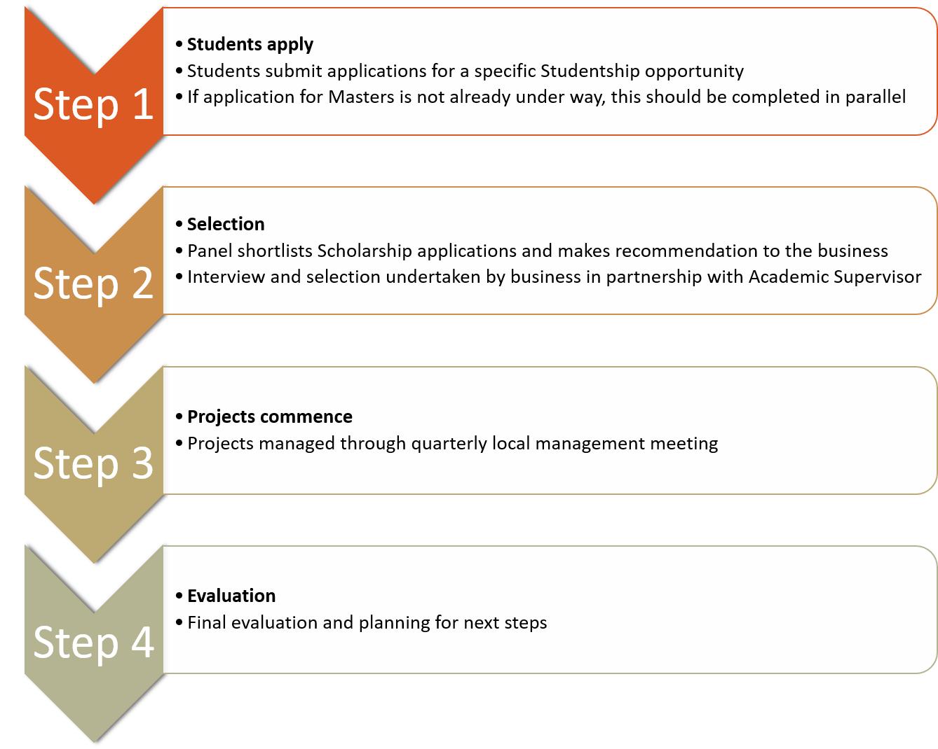

|  |
| --- |
| **International Students:**  If you hold a Tier 4 visa, or will need a Tier 4 visa (now Student Route visa) to study at the University of Plymouth, please note that the details of this Studentship scheme have been discussed with our UKVI Compliance and International Student Advice teams. This Studentship opportunity involves project work delivered as part of the student’s studies, and collaboration with employers to deliver the project, but not employment or any work placement with employers. Therefore, we are satisfied that this will not be classified as “work” in any capacity by UKVI. |

Students and potential students can get involved with the Masters R&D Studentship in the following two ways:

1. To ensure you are kept informed of new studentship opportunities as they go live, please complete the Expression of Interest form at the end of this document and return it, along with your current CV and portfolio, to [plymcreative@plymouth.ac.uk](mailto:plymcreative@plymouth.ac.uk) copying in [sarah.holcombe@plymouth.ac.uk](mailto:sarah.holcombe@plymouth.ac.uk). This will ensure you are informed of all new opportunities which go live under the scheme but will not be considered as an application for a specific studentship opportunity.

AND

1. If applying for a specific studentship opportunity, follow the specific application guidance within the opportunity you are applying for.

If you have any questions please do not hesitate to contact:

**Sarah Holcombe, iMayflower Knowledge Exchange Specialist**

**E:** [sarah.holcombe@plymouth.ac.uk](mailto:sarah.holcombe@plymouth.ac.uk) **T:** 07458 127919

**About iMayflower**

iMayflower is designed to build Plymouth’s Creative Industries and nurture creative people power across the city. Delivered by a consortium comprising the University of Plymouth, Plymouth City Council, Destination Plymouth, Mayflower 400, Plymouth College of Art and the Real Ideas Organisation (RIO), the project includes a £3.5million grant from the Department for Digital, Culture, Media and Sport’s Cultural Development Fund, which invests in creative, cultural and heritage initiatives that lead economic growth and productivity.

*This activity is part of the iMayflower project and has been supported by* ***The Department for Digital, Culture, Media and Sport who fund the Cultural Development Fund which is administered by Arts Council England.***



**STUDENT EXPRESSION OF INTEREST**

|  |  |
| --- | --- |
| **Grant Title** | iMayflower Masters R&D Studentship |
| **Applicant name** |  |
| **Contact email address** |  |
| **Contact telephone number** |  |
| **Programme of study**  (If a current student, please start CURRENT and confirm which Masters you are studying and when you are due to complete your studies.  If you are considering joining a Masters in 2021, please state NEW and confirm which programme you are applying for) |  |
| **Please detail what area of research you are interested in pursuing and provide outline information about your skill set**  (Up to 500 words) |  |
| **Tell us how you will benefit from the proposed studentship**  (Up to 300 words) |  |

*\* Please note places will be extremely limited*